|  | **National University of Computer and Emerging Sciences (Lahore)** | | | |
| --- | --- | --- | --- | --- |
| **Course:** | **Applied Programming** | **Code:** | **CS-0319** |
| **Section:** | **MSCS-2A** | **Semester:** | **Spring 2024** |
| **Time:** | **25 minutes** | **TotalMarks:** | **10** |
| **Date:** |  | **Roll no:** |  |
| **Name:** |  | | |

**Question#1: [5]**

Consider the following list of values to be inserted into the Binary Search Tree (BST): 5, 10, 15, 20, 25, 30, 35.

**Draw** the Binary Search Tree that results from inserting the above list of values in order.

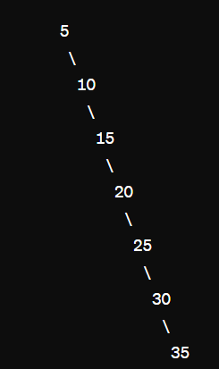

| Tree after insertion: |
| --- |

Consider the following piece of C++ code:

**TreeNode* leftRotate(TreeNode* root) {**

**TreeNode* newRoot = root->right;**

**root->right = newRoot->left;**

**newRoot->left = root;**

**return newRoot;**

**}**

**TreeNode* RotationThrice(TreeNode* root) {**

**for (int i = 0; i < 3; ++i) {root = leftRotate(root);}**

**return root;**

**}**

Suppose the function **RotationThrice(TreeNode* root)**is called for the root node of the above drawn tree. Redraw the updated tree below:

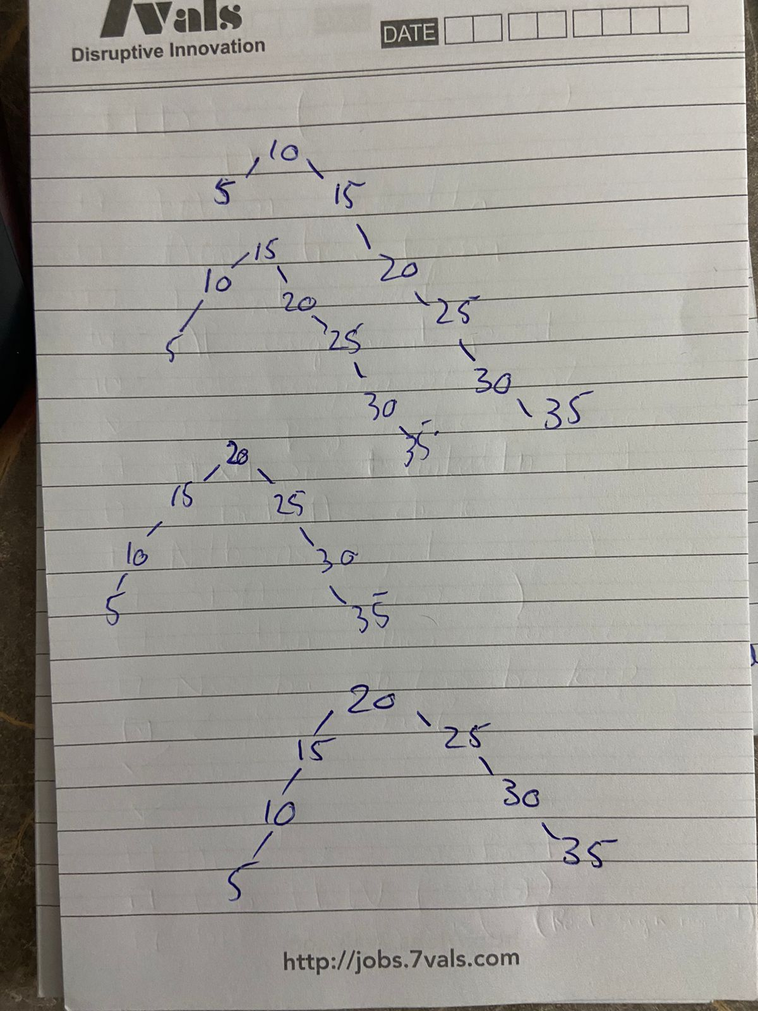

| Updated Tree: |
| --- |

**Question#2: [2+3]**

You are provided with an unordered array of integer values. Your task is to create an integer Binary Search Tree (BST) from this array using an insert function:

**1)Node* insertIntoBST(int * arr, int size)**

Once the BST is constructed, count the number of subtrees within it recursively where all nodes lie within a given range [L, R] (Subtrees here refer to any node and its descendants):

**2)int countSubtreesInRange(Node* root, int L, int R)**

**NOTE:** you may create other helper functions (if needed)

**For Example:** Consider the following BST. The total number of subtrees with nodes in range [5, 20] is 6.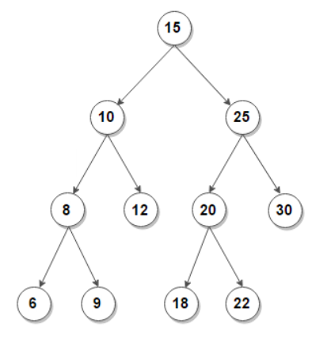

The subtrees are: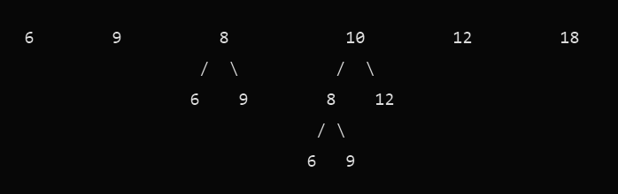

| TreeNode* insertIntoBST(TreeNode* root, int val) {  if (root == nullptr) {  return new TreeNode(val);  }  if (val < root->val) {  root->left = insertIntoBST(root->left, val);  } else {  root->right = insertIntoBST(root->right, val);  }  return root;  }  TreeNode* insertIntoBST(int* arr, int size) {  TreeNode* root = nullptr;  for (int i = 0; i < size; ++i) {  root = insertIntoBST(root, arr[i]);  }  return root;  } |
| --- |
| int countSubtreesInRange(TreeNode* root, int L, int R) {  if (root == nullptr) {  return 0;  }  if (root->val < L) {  return countSubtreesInRange(root->right, L, R);  }  if (root->val > R) {  return countSubtreesInRange(root->left, L, R);  }  // If root->val is within range, count the subtrees in left and right subtrees recursively  return (1 + countSubtreesInRange(root->left, L, R) + countSubtreesInRange(root->right, L, R) );  } |